**Group Members: Zeynep Atalay, Cole Saucier, Emily Moy**

**Link to website**: <https://zeynepata1ay.github.io/alzheimers-final-project/>

Link to GitHub repo: <https://github.com/zeynepata1ay/alzheimers-final-project>

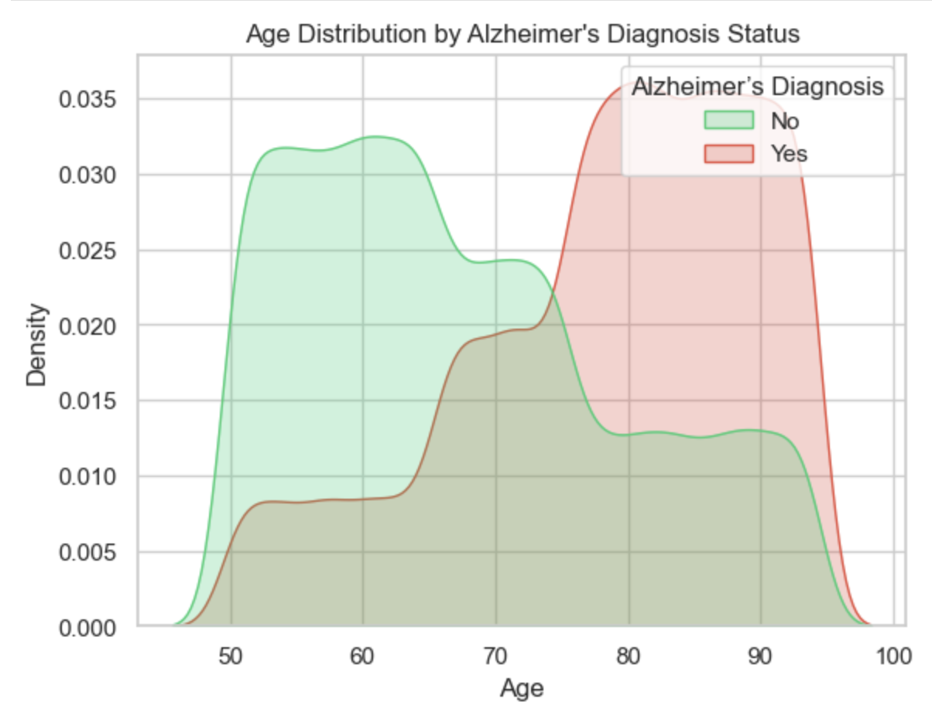

**Density plot design**: A density plot was created with Seaborn in order to clearly view the age differences of the groups with positive or negative Alzheimer’s diagnoses; it was useful to be able to overlay the two groups. The format also allowed us to see if the data was skewed towards different sides. As seen in the graph, the “No” group skews towards younger ages, while the “Yes” group skews towards older folks. Density plots depict smooth curves in the graph, which are visually appealing.

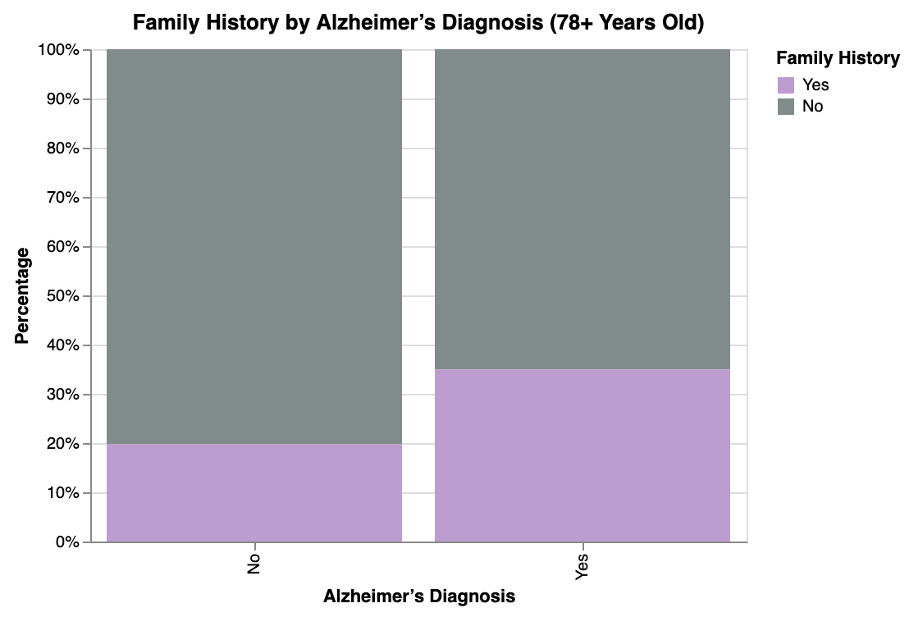

**Family history design**: A stacked bar plot created with Altair to show the comparison between the groups of people with positive and negative Alzheimer’s diagnoses. The stacked design allowed us to easily view the proportions of each diagnosis group of those with and without a family history of the disease. Since the bars were set to the same height, comparisons for the proportions could easily be determined. This design also uses space efficiently, using two columns whereas a standard bar plot would use four.

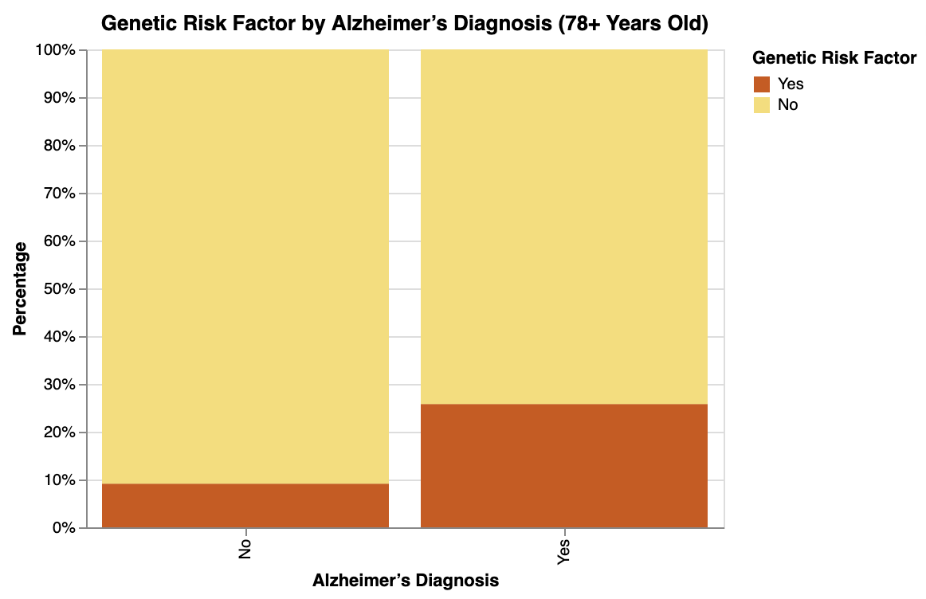

**Genetic risk design**: A stacked bar plot was created with Altair to show the comparison between the groups of people with positive and negative Alzheimer’s diagnosis. The stacked design allowed us to easily view the proportions of each diagnosis group of those who were and were not genetically predisposed to the disease. Since the bars were set to the same height, comparisons for the proportions could easily be determined. This design also uses space efficiently, using two columns whereas a standard bar plot would use four.

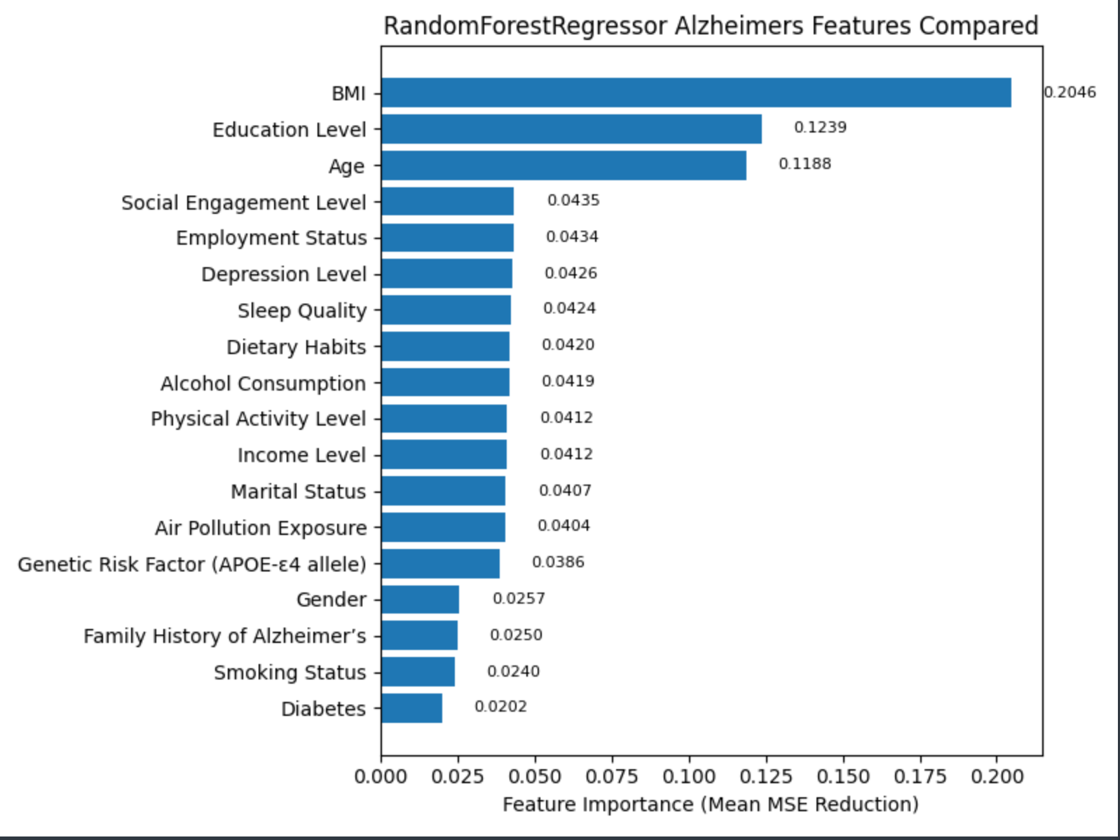

**RandomForestRegressor Importance Design:**

This feature importance graph compares the predictive power of various features on Alzheimer's diagnosis. It clearly shows the most impactful variables. One design element instrumented was the displayed feature importance values.. As reasoning for including all the variables, we felt that it was warranted for constancy and as a basis for the interactive chart (D3) despite it being a lot of information.

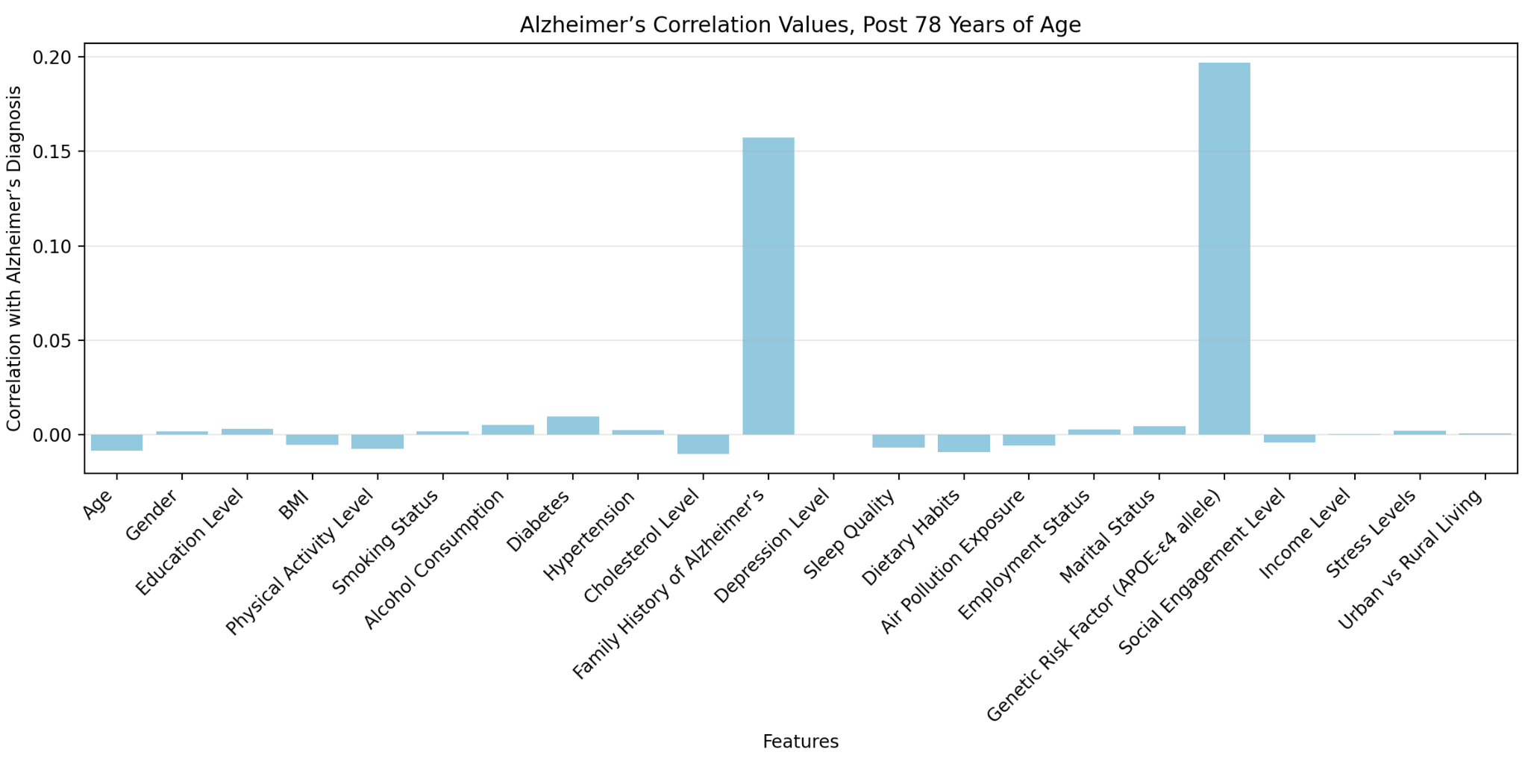

**Alzheimer's Correlation design:** A bar plot was used to further simplify the correlation matrix for Alzheimer’s diagnosis. The bar chart allows us to tangibly compare small differences (correlations of 0.1-0.18) of the matrix. Including all the variables shows a lack of simple correlation for most variables.

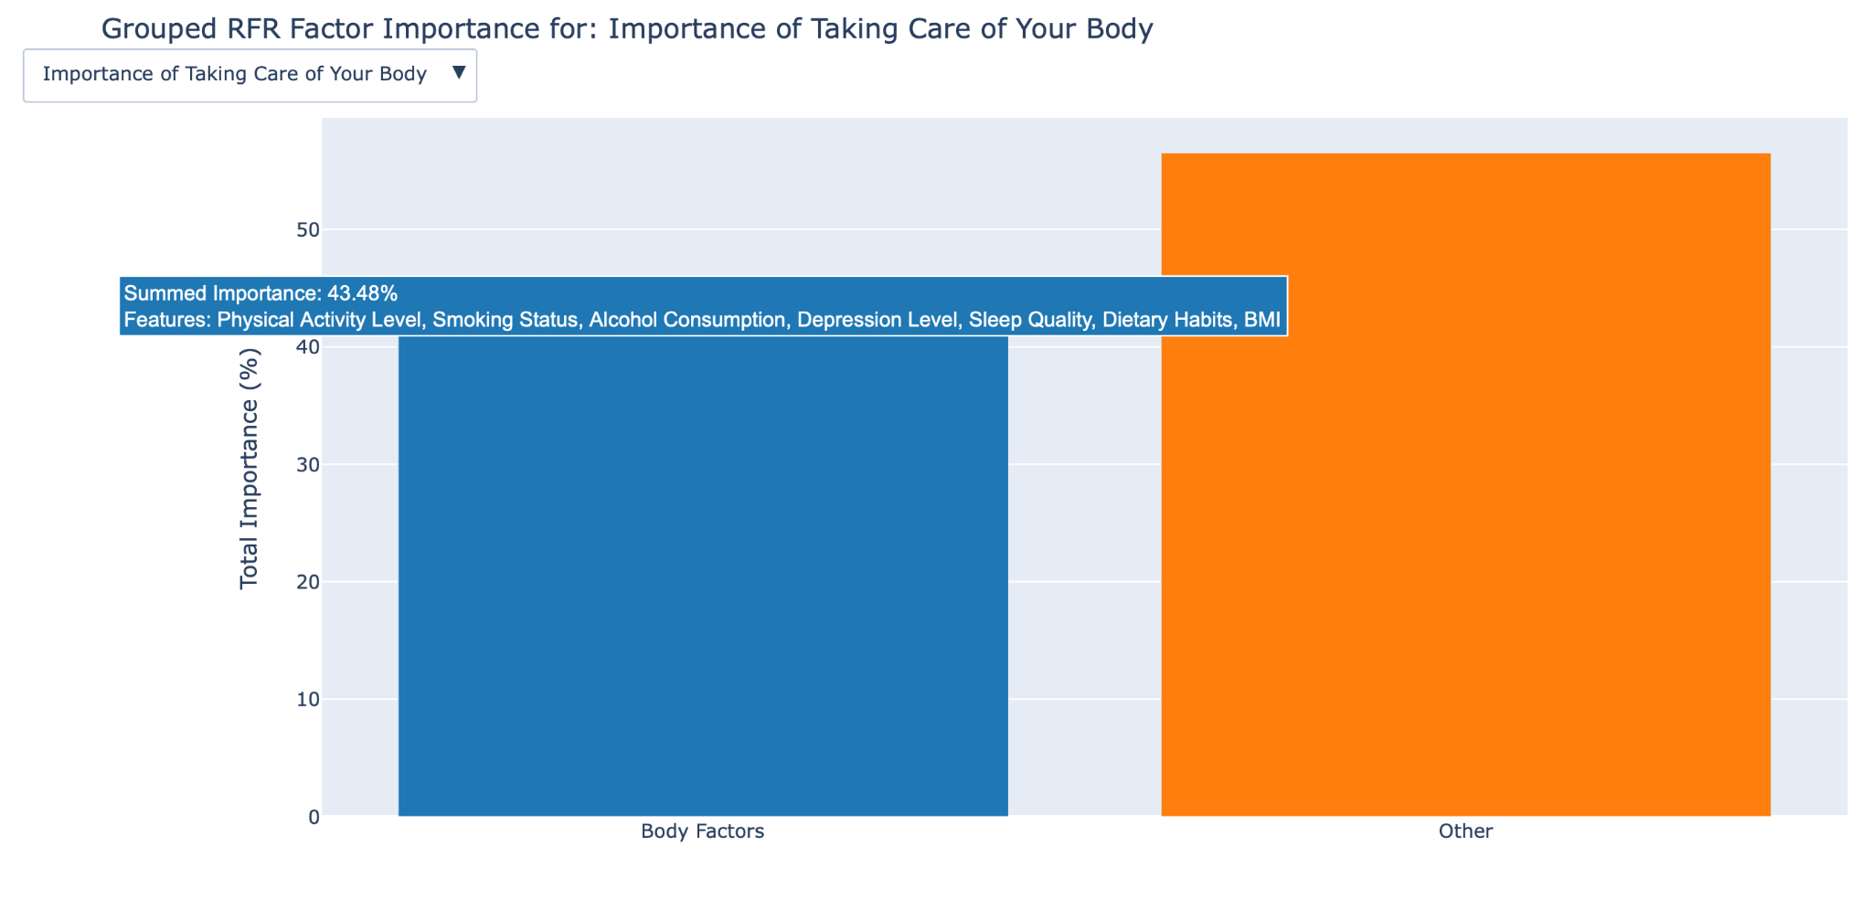

**Interactive Feature Importance design:** The interactive element allows users to group RFR feature importance values and answer basic questions about Alzheimer's predicting. Conveniently this combines 3 visualizations into one. The three questions are “Nature vs. Nurture” , “Importance of a Healthy Body”, and “Impact of Life Choices”. Hovering over the bars shows which variables were grouped for a total. It shows the breadth of impact personal everyday choices have on preventable Alzheimer’s disease.